Project Proposal

Course title: IOT Laboratory

Course code: CSE-460
4th Year 1st Semester Examination 2025

Date of Submission: 28/02/2026

Submitted to-

Dr. Md. Ezharul Islam, B.SC.(JU), M.ENGG.(JAPAN), PHD(JAPAN)
Professor
Department of Computer Science and Engineering
Jahangirnagar University

&

Samsun Nahar Khandakar
Assistant Professor
Department of Computer Science and Engineering
Jahangirnagar University
Savar, Dhaka-1342

Class Roll | Exam Roll | Name
383 | 210903 | Abdullah Nazmus-Sakib
379 | 210899 | Shah Sultan
391 | 210911 | Md Khaled Mahmud

1. Title
IoT-Based Smart Patient Turning and Bed Monitoring System for Bedridden Patients

2. Idea
Bedridden patients who are unable to change their body position for long periods are at high risk of developing pressure ulcers (bed sores). Continuous manual monitoring by caregivers is difficult and sometimes delayed.
The main idea of this project is to design and develop an IoT-based smart system that continuously monitors the patient’s body pressure, position duration, temperature, and humidity conditions. The system will generate alerts if the patient remains in the same position for an extended time, helping caregivers prevent pressure sores and improve patient care.

3. Features
- Pressure Monitoring System – Detects body pressure using sensors placed under the mattress.
- Time-Based Position Alert – Sends alert if the patient stays in the same position for more than a predefined time (e.g., 2–3 hours).
- Temperature & Humidity Monitoring – Detects moisture and sweating conditions.
- Mobile App Notification (IoT-Based) – Sends real-time alerts to caregivers.
- Buzzer Alert System – Provides local sound alert.
- Cloud Data Storage – Stores patient data for remote monitoring.
- Automatic Bed Tilt (Optional Advanced Feature) – Slightly adjusts bed angle using a motor system.

4. Methodology

Step 1: Data Collection
- Pressure sensors (FSR or Load Cell) will be placed under the mattress to measure body pressure.
- A DHT22 sensor will monitor temperature and humidity around the patient.

Step 2: Data Processing
- ESP32 microcontroller will collect sensor data.
- The system will track how long the pressure remains unchanged.
- If the same pressure condition continues for a predefined time, it will trigger an alert.

Step 3: Alert System
- A buzzer will activate locally.
- A notification will be sent to the caregiver’s mobile application via WiFi.

Step 4: Cloud Integration
- Sensor data will be uploaded to a cloud platform (Blynk or Firebase).
- Doctors or caregivers can monitor the patient remotely.

Step 5 (Optional Advanced Feature)
- A servo motor or linear actuator may slightly tilt the bed automatically to reduce pressure.

5. Components Required

Main Controller
- ESP32 (WiFi-enabled microcontroller)

Sensors
- FSR (Force Sensitive Resistor) or Load Cell
- HX711 Amplifier Module (for Load Cell)
- DHT22 Temperature & Humidity Sensor

Output Devices
- Buzzer
- LCD Display (optional)

Actuator (Optional)
- Servo Motor or Linear Actuator

Power Supply
- 5V / 12V Power Adapter

IoT Platform
- Blynk or Firebase Cloud

📊 Block Diagram
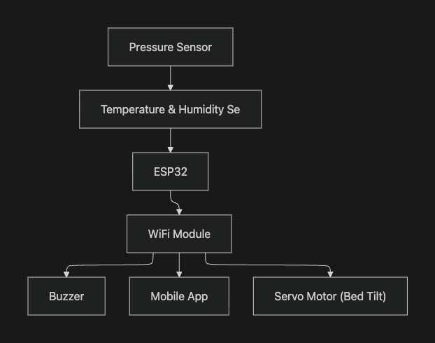

🎯 Expected Outcome
- Reduction of pressure ulcer risk
- Improved patient safety and comfort
- Reduced caregiver workload
- Remote health monitoring capability
- Low-cost smart healthcare solution

1. Title
AI-Driven Personalized IoT Healthcare Monitoring System for Multi-Disability Patients

2. Idea
This project aims to develop an intelligent healthcare monitoring system that learns and adapts to an individual patient’s unique physiological patterns instead of relying on fixed medical thresholds.
The system continuously collects health data and builds a personalized baseline profile. It detects anomalies relative to the patient’s normal condition and provides early warnings of potential health deterioration.
This approach is especially useful for patients with chronic illnesses or multiple disabilities, whose normal vital signs may differ significantly from standard values.

3. Methodology
- Long-Term Data Collection:
Sensors continuously gather physiological data.
- Data Transmission:
Microcontroller sends data to cloud storage.
- Baseline Modeling:
System analyzes historical data to establish personal health patterns.
- AI/Statistical Analysis:
Algorithms detect deviations from the individual baseline rather than general thresholds.
- Anomaly Detection:
Identify abnormal trends such as gradual health decline or sudden changes.
- Alert Generation:
Notify patient or caregiver when significant anomalies occur.
- Visualization:
Dashboard displays trends, history, and health insights.

4. Components
Hardware:
- ESP32 microcontroller
- Heart rate & SpO₂ sensor (MAX30102)
- Temperature sensor
- Activity sensor (accelerometer)
- Optional blood pressure or glucose sensor
- Wi-Fi communication module
- Battery supply
Software:
- Arduino IDE
- Cloud database
- Python / ML tools for analysis
- Dashboard interface

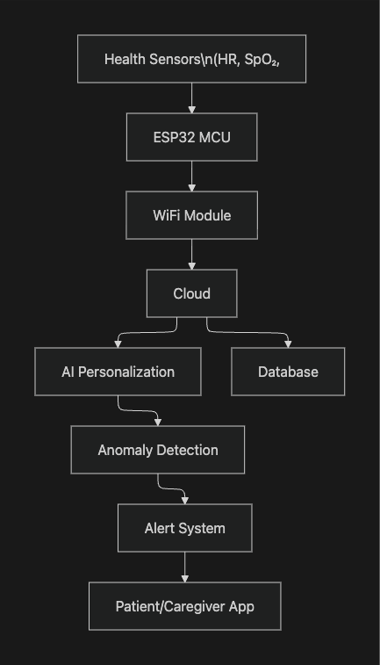
5. Block Diagram

1. Title
Autonomous IoT-Based Emergency Detection and Response System for Disabled Individuals

2. Idea
The project aims to develop a smart IoT system that continuously monitors a disabled individual’s health and physical condition and automatically detects emergencies such as falls, abnormal vital signs, or immobility. Upon detecting a critical situation, the system will autonomously trigger alerts to caregivers or emergency services without requiring user intervention.
This system is particularly useful for individuals living alone who may be unable to call for help during emergencies.

3. Features
- Real-time health monitoring (heart rate, SpO₂, temperature)
- Fall detection using motion sensors
- Inactivity detection
- Location tracking via GPS
- Automatic emergency alert (SMS/Call/App notification)
- Multi-sensor decision mechanism
- No manual input required
- Caregiver monitoring dashboard
- Local alarm/buzzer activation

4. Methodology
- Collect physiological and motion data using wearable sensors.
- Process sensor data using a microcontroller (ESP32).
- Implement emergency detection logic combining vital signs and motion patterns.
- Identify abnormal conditions such as fall + immobility or critical health parameters.
- Transmit emergency data to cloud/server via Wi-Fi or GSM.
- Automatically notify caregivers with patient status and location.
- Provide real-time monitoring through a web/mobile interface.
- Test system performance for accuracy and reliability.

5. Components
Hardware Components
- ESP32 Microcontroller
- MAX30102 Heart Rate & SpO₂ Sensor
- MPU6050 Accelerometer & Gyroscope
- Temperature Sensor (LM35/DS18B20)
- GPS Module (NEO-6M)
- GSM Module (SIM800L) or Wi-Fi
- Buzzer / Alarm
- Rechargeable Battery
Software Components
- Arduino IDE
- IoT Cloud Platform (ThingSpeak/Firebase)
- Web or Mobile Application

6. Block Diagram
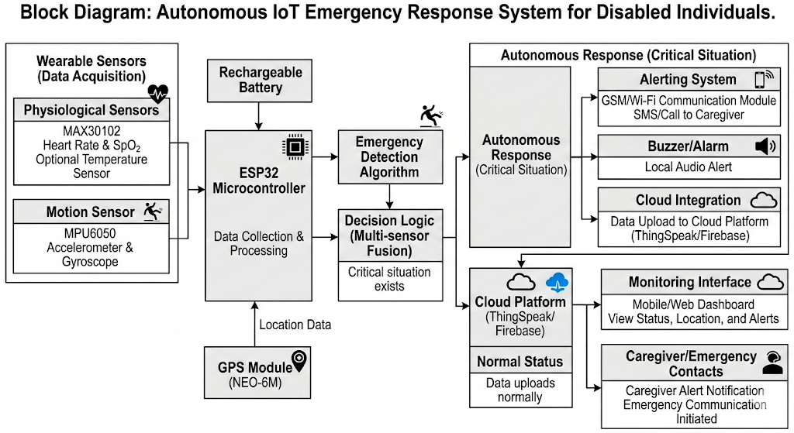

1. Title
IoT-Enabled Smart Wheelchair with Obstacle Detection & Fall Prevention System

2. Idea
This project proposes an intelligent wheelchair equipped with sensors, machine learning, and IoT connectivity to enhance mobility safety for physically disabled and elderly individuals. The system continuously monitors obstacles, terrain conditions, user fatigue, and stability to prevent accidents such as collisions or tipping. It also provides real-time location tracking and emergency communication with caregivers.
The goal is to increase user independence while ensuring safety without constant human supervision. According to the provided document, the system integrates real-time sensing, autonomous safety actions, and remote monitoring through cloud services and mobile applications.

3. Features
- Automatic Braking: Stops the wheelchair when obstacles are too close
- Slope & Terrain Detection: Prevents operation on unsafe inclines
- Anti-Tip Mechanism: Stabilizes the wheelchair on uneven surfaces
- Real-time GPS Tracking: Enables caregiver monitoring and geofencing
- Fall/Tip Prediction: Uses sensor data and ML to detect instability
- Fatigue Detection: Monitors prolonged use and alerts the user
- Voice Command Control: Hands-free navigation using offline speech recognition
- Motor Encoder Feedback: Detects wheel slip or malfunction
- Emergency SOS Button: Sends immediate alert with location
- Battery Monitoring: Warns about low power

These features collectively improve safety, autonomy, and usability.

4. Methodology
The system operates through continuous data acquisition, processing, and response:
Obstacle Detection:
Ultrasonic sensors measure distances around the wheelchair. If an object enters a critical zone, warnings or automatic braking are triggered.
Fall Prevention:
An IMU measures tilt and acceleration. A machine learning model calculates tipping probability. When risk exceeds safe thresholds, the system slows down or stops.
Fatigue Monitoring:
Grip pressure sensors analyze user strength and movement patterns over time. If fatigue is detected, alerts are issued and speed may be reduced.
Voice Recognition:
Offline speech recognition enables control commands such as forward, stop, and turn without requiring internet connectivity.

5. Components

Sensors
- Ultrasonic Sensors (HC-SR04) — obstacle detection
- IMU (MPU6050) — motion and tilt sensing
- Barometer (BMP280) — slope measurement
- Pressure Sensors — grip strength monitoring
- GPS Module — location tracking
- Motor Encoders — speed feedback

Control & Communication
- ESP32 Microcontroller — main processing unit
- Motor Driver — controls wheelchair motors
- WiFi Module — cloud connectivity
- GSM Module (optional) — emergency communication

Power & Mechanical
- Main battery for motors
- Control battery for electronics
- Anti-tip servo motor
- Protective enclosure
These components form an integrated assistive system as described in the source document.

6. Block Diagram
